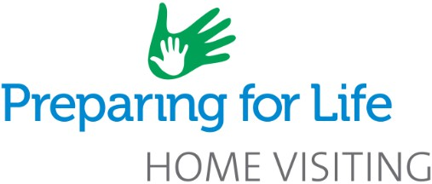

Are you pregnant?

Preparing for Life's
Home Visiting Programme
is for all families expecting a new baby who would like FREE,
non-judgmental support from pregnancy to school!

Home Visiting Programme for Families
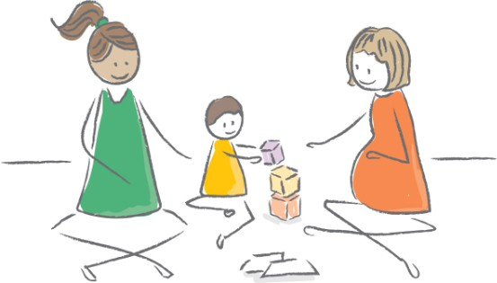
Our friendly family Home Visitor will support you as a parent with tips on:
- Taking care of yourself during pregnancy
- Preparation for labour and birth
- Feeding and sleep routines
- Play
- Enjoying your baby
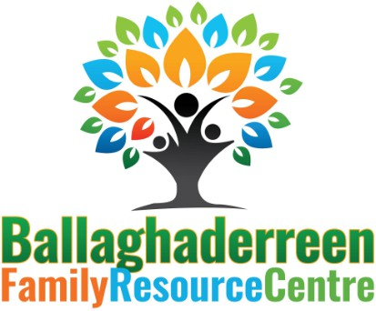



- Enjoying being a parent
@Ballaghaderreen Family Resource Centre
@Ballaghaderreen_frc
To find out more or sign up for these services today, scan this QR code or contact Ballaghaderreen Family Resource Centre on
094 986 0767 or 086 822 4887
Email:PFLCoordinator@ballaghaderreenfrc.ie Ballaghaderreen Family Resource Centre, New Street, Ballaghaderreen, Co. Roscommon F45EK13

