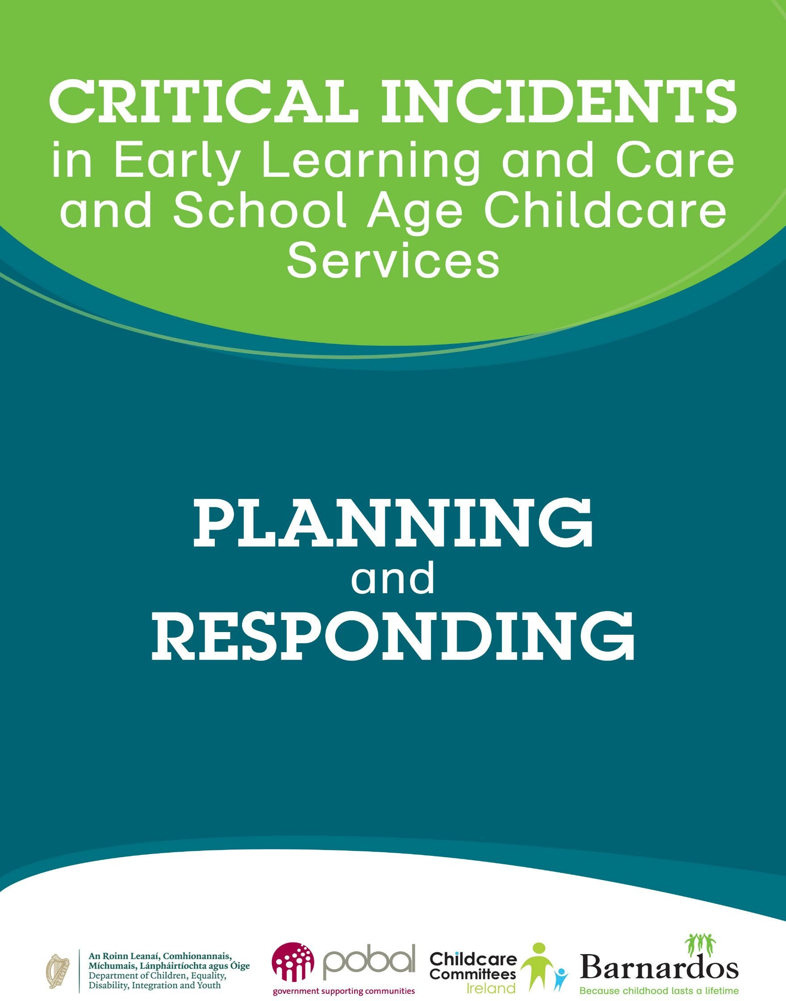

Critical Incidents in Early Learning and Care

and School Age Childcare Services: Planning and Responding

© 2023 Barnardos

ISBN: 978-1-906004-90-3

Published by Barnardos Christchurch Square Dublin 8

CHY 6015 / RCN 20010027

Developed on behalf of the Department of Children, Equality, Disability, Integration and Youth by the Critical Incident National Working Group with Barnardos.

We would like to acknowledge County Childcare Committees for their feedback on this document through Childcare Committees Ireland; Galway CCC for the use of their Critical Incident Emergency Preparedness Risk Assessment; and The National Education Psychology Service and Tusla for reviewing this document.

**Contents**

Introduction 4

Part 1 GUIDANCE

What is a Critical Incident? 5

Why Plan for Critical Incidents? 5

Roles and Responsibilities 6

Policy, Procedures and Statements 6

Developing a Critical Incident Plan 8

1. Prevent 9
2. Prepare 9
3. Respond 12
4. Review 15

PART 2 FORMS, CHECKLISTS AND TEMPLATES

Prevention Checklists 16

Emergency Preparedness Risk Assessment and Plans 20

Responding to a Critical Incident – Poster 25

Response Records 26

Communication Templates 29

Useful Links 33

## Introduction

All Early Learning and Care (ELC) and School Age Childcare (SAC) services are required to have a service level Critical Incident Plan as outlined in the Tusla Quality and Regulatory Framework (QRF) and the National Quality Guidelines for School Age Childcare Services. All employers must ensure, so far as is reasonably practicable, the safety, health and welfare at work of their employees, under the Safety, Health and Welfare at Work Act 2005.

This guide has been developed from previous guidance on critical incidents planning, including the Critical Incident Plan Toolkit and the extensive work of the National Educational Psychological Service (NEPS), to support ELC and SAC services to think about and plan for critical incidents and to have practical supports in place should it be necessary to respond to a critical incident.

It also clarifies the roles and responsibilities at national and local levels when responding to critical incidents.

Incidents may occur outside normal working hours or may require a response outside normal hours including evenings, weekends or holidays.

This guide does not cover every aspect of what settings should do in relation to emergency planning. Settings must comply with their legal responsibilities, including health and safety legislation, and should seek legal advice as needed. Risk assessments, policies and plans should be continuously reviewed and updated to reflect new and updated guidance.

# PART 1 GUIDANCE

## What is a Critical Incident?

The World Health Organisation (WHO) describes a critical incident as ‘an event out of the range of normal experience – one which is sudden and unexpected’, that involves a threat to life or loss of life, and can include elements of physical or emotional trauma or loss. A critical incident may also involve severe damage to buildings or facilities such that the damage causes risk to children and adults or the service cannot operate.

Such events have the capacity to bring about significant distress in an individual, or a group of people, and/or overwhelm or threaten to overwhelm the normal coping capacity of a service and those in charge of its operation.

While critical incidents in Early Learning and Care and School Age Childcare are rare, they can happen in any setting.

Examples of critical incidents that may affect an ELC or SAC setting include:

* Incidents on outings (e.g., a child going missing)
* Public health incidents (e.g., a significant infectious disease incident)
* Severe weather (e.g., extreme heat, flooding, storms or snow)
* Serious accident, injury or trauma to a child or member of staff (e.g., an attack or a transport accident)
* The death of a child in the setting or a child who attends the service (e.g., due to sudden infant death syndrome, an accident or a medical condition)
* Significant damage to property (e.g., fire, accidental damage)
* Criminal activity (e.g., child abduction, bomb threat, anti-social or threatening attack, intruder, cyber security attack)
* A disaster or public order incident in the local community
* Loss of water or utilities

Examples of incidents that have occurred in Ireland in recent years include a missing child, death of a child in a service, a road death of a child attending a service, death of parents, siblings or a staff member, death by suicide or murder, young children stabbed as they left school to go to the service, a shooting near a service and severe fire, flood or storm damage.

Critical events may also happen in the local community near a setting or involve children or staff members from the service.

## Why Plan for Critical Incidents?

Emergencies usually come with little or no warning and can result in confusion, disruption and sometimes devastation.

* ELC and SAC providers have a duty of care to all those who use, visit and work in their services.
* An early, appropriate and systematic response can help to reduce the effects of stress and minimise the possibility of further problems developing later.
* A Critical Incident Plan will outline the appropriate actions to take at the initial stage of an incident and these will be known and understood by staff members. Having a plan in place in advance of an incident ensures appropriate actions at a time of heightened feelings and anxiety.
* Appropriate communication and accurate information will be provided for all children, staff members and parents and others who may be involved.
* The primary focus of the response can be on providing care and minimising further stress on children, parents and staff members.
* A service level Critical Incident Plan is a requirement of the Tusla Quality and Regulatory Framework (QRF). The National Quality Guidelines for School Age Childcare Services also state that plans should be developed, practised and implemented to manage accidents and incidents effectively.

**Preparation and planning are key in ensuring a comprehensive and appropriate response to a critical incident. They also help to limit the potential long-term impacts of the incident.**

## Roles and Responsibilities

The Department of Children, Equality, Disability, Integration and Youth (DCEDIY) will:

* Oversee the development and delivery of the Critical Incident Framework
* Co-ordinate responses from other government departments or agencies as appropriate
* Ensure an adequate response to incidents that are escalated to a national level
* Develop CPD plans and responses to ensure all educators have access to relevant training

Tusla will:

* Respond to critical incidents through the notification of incidents and feedback and concerns processes
* Follow up with services, which may necessitate an inspection/visit
* Retain a log of all incidents notified to Tusla
* Nationally track numbers and details of critical incidents

Childcare Committees will:

* Provide training in relation to critical incidents and support the development of service level Critical Incident Plans
* Make connections through the local CYPSC to agree a local response
* Respond and offer service support when a critical incident happens
* Inform the DCEDIY of all critical incidents

Early Learning and Care and School Age Childcare Services will:

* Prepare a Critical Incident Plan that includes information as to the staff team’s roles and responsibilities in the event of an incident
* Have an up-to-date Policy on Accidents and Incidents
* Ensure all other required policies, procedures and statements are up-to-date
* Inform Tusla and your local County Childcare Committee when a critical incident happens
* Respond in line with DCEDIY guidance when a critical incident happens

## Policy, Procedures and Statements

All services are required to have a clear set of policies, procedures and statements as outlined in the Child Care Act 1991 (Early Years services) Regulations 2016 and the [Child Care Act 1991 (Early Years Services)](https://www.irishstatutebook.ie/eli/2018/si/575/made/en/print) [(Registration of School Age Services) Regulations 2018.](https://www.irishstatutebook.ie/eli/2018/si/575/made/en/print) There are additional recommended policies in the [National Quality Guidelines for School Age Childcare Services](https://assets.gov.ie/88025/5e6c734d-7d21-47f2-ae28-b84b581939d9.pdf) and in the [Tusla practice guidance for](https://www.tusla.ie/uploads/content/4572-TUSLA_QRF_POLICY_PROCEDURES_LR.pdf) [developing policies, procedures and statements.](https://www.tusla.ie/uploads/content/4572-TUSLA_QRF_POLICY_PROCEDURES_LR.pdf)

The policies relating to fire safety, accidents and incidents, risk management, first aid, health and safety, outings and safe sleep will be most relevant for critical incidents, but you will also need to consider other policies and procedures such as the supervision policy, recruitment and safe staffing/management of staff absence, as well as those relating to infection control, confidentiality and data protection as appropriate.

Among other information, policies, procedures and statements will include information about:

* Processes and procedures to help prevent accidents and incidents
* The procedures that will take place should an incident arise
* How the incident will be communicated and to whom
* How the incident will be recorded
* How records will be shared

Guidance on the content for the policies required under the Child Care Act 1991 (Early Years services) Regulations 2016 is contained in the [Tusla Quality and Regulatory Framework (QRF).](https://www.tusla.ie/services/preschool-services/early-years-providers/early-years-provider-resources/early-years-quality-and-regulatory-framework/) This guidance is also useful for School Age Childcare policies.

For example, QRF Appendix 7 provides information for the content of the Fire Safety Policy, QRF Appendix 9 for the Outings Policy and QRF Appendix 10 for Accidents and Incidents. Guidance on content for other policies relevant to preventing and responding to critical incidents is also provided in the QRF appendices.

Your service Policy on Accidents and Incidents**1** should specify:

* + The measures to be taken to prevent accidents and incidents
  + The procedures to be followed when an accident or incident involving a child occurs while the child is attending the service, including the steps to take to contact the parent or guardian of the child or the emergency services if necessary
  + The way to keep a record of the accident or incident
  + The way a record should be shared with the parent or guardian of the child involved in the accident or incident
  + Procedures to prevent recurrence of the accident or incident, i.e. risk assessments

**It is essential that all of your policies are clearly written, up-to-date****2****, and that all staff members are familiar with them and understand their roles and responsibilities. Policies should also be made available and accessible to parents.**

1 Quality and Regulatory Framework – Full Day Care Service and Part-Time Day Care Service pp. 109-110.

2 Reviewed on an annual basis or more often if required

## Developing a Critical Incident Plan

Taking time to consider and plan for possible actions before an emergency happens will support a more appropriate and professional response should a critical incident occur.

Your **Critical Incident Plan** will cover four key elements:

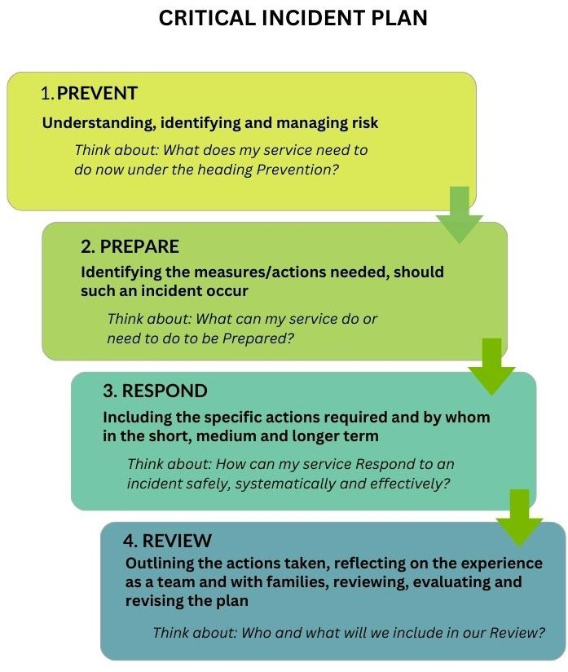

**All ELC and SAC services are required to have a service level plan to manage accidents and incidents effectively as outlined in the Tusla Quality and Regulatory Framework (QRF) and the National Quality Guidelines for School Age Childcare Services.**

**CHILDREN’S RIGHTS IN DEALING WITH CRITICAL INCIDENTS**

The rights and voice of the child must not be overlooked when dealing with any impactful incident in the service or in the wider community. For example, if a service has to close following an incident, children’s right to ECCE days must be considered. The importance of children re-establishing their routine, and reconnecting with their known educators and their friends must be taken into account and facilitated in whatever ways possible and as soon as possible.

Children’s rights should always be a key consideration when planning how to prevent, prepare for, respond to and review a critical incident.

## Prevent

Prevention in this context means the staff members in the service being aware of and implementing the service’s policies and procedures relating to the health, safety, protection and wellbeing of all children and adults in the setting. Essential elements include induction of all staff members, staff training, awareness and compliance with regulations, and timely review of all policies, procedures and statements.

Regular staff team meetings and staff supervision are essential to develop and maintain appropriate systems, procedures and processes, and a culture of safety and risk management. Communication with and support for families is also an important aspect of preventing accidents or incidents.

⇒ *See pages 16 to 19 for Prevention Checklists.*

**You should make contact with your local City and County Childcare Committee to help identify the additional supports available.**

## Prepare

Preparing for a critical incident ensures the correct actions are taken at a time of great stress. In a larger setting (more than 2 staff members), a service level Critical Incident Plan may identify individual named staff members who would form the **Critical Incident Team** (and deputies should the first named staff members not be present) as well as the roles and responsibilities they will assume.

This might include named team members who will take on the following roles:

* + Critical Incident Team Leader
  + Deputy Critical Incident Team leader
  + Children’s safety and wellbeing lead
  + Garda Liaison
  + Community Liaison
  + Media Liaison
  + Parent/Guardian Liaison
  + Critical Incident Administrator
  + Service owner/Board of Management representative

In a small service many of these roles will fall to the service owner or manager.

Staff members’ roles and responsibilities at the time of an incident should be as per the Critical Incident Plan for your service. It is important to base the plan on the individual circumstances of your service.

The Critical Incident Team will need to prepare an Evacuation Plan (see below), ready to be activated should a fire or other emergency occur in or near the setting.

⇒ *See pages 20 to 21 for Emergency Preparedness Risk Assessment*

⇒ *See pages 22 to 24 for Sample Plans*

**Advance training for all staff team members and familiarisation with the Critical Incident Plan will support a calm, appropriate and professional response during difficult situations and events.**

**It may be useful to take staff members through some possible scenarios as part of a training exercise.**

### Critical Incident Folder

It is recommended that the service, through their Critical Incident Team, develop a **Critical Incident Folder**

outlining the steps to be taken when a critical incident occurs. This folder will include:

* + - An up-to-date facility floor plan and maps outlining fire exits and location of essential services (such as First Aid kit, water, electricity)
    - A service evacuation plan (including location of the assembly point)
    - Agreed actions to be taken by the Critical Incident Team
    - Agreed actions to be taken by all staff members
    - A list of relevant contact details including address and Eircode of setting, Emergency Services, GP, An Garda Síochána, Local Authority, County Childcare Committee (CCC), Tusla, and Pobal
    - Contact information for staff members and next of kin
    - A copy of each child’s admission form, to include contact information for parents/guardians, the child’s medical information, GP contact and allergy information (if any) and any other necessary information to ensure the child’s safety and wellbeing. As this is confidential information, access should be limited to necessary persons only.
    - Relevant medical information for staff members (including allergies) included with their consent

The daily sign-in sheet should be kept to hand and added at the time of the critical incident.

The Critical Incident Folder can be stored electronically, to be accessed on a device such as a mobile phone or tablet in the event of an emergency. It is advisable to have paper copies of all plans and contact information for all children, parents and guardians, staff members and their next of kin available in the event that it is not possible to access digital information.

The folder should be stored securely but be easily accessible by the person in charge, and all staff members made aware of its location.

All documents created in response to the critical incident, including checklists used, log records, and communications to families, media or others as necessary, should be kept on file in keeping with GDPR requirements, and available for inspection by an authorised officer.

The list of relevant contact details should be displayed at various easily accessible points around the setting.

### Business Continuity Planning

**Business Continuity Planning** involves working out how to continue to operate the service under adverse conditions or after an emergency event. Examples might include fires in buildings, utility breakdowns, impacts of natural events such as severe snow, ice, storms and floods, and national incidents such as a pandemic.

Planning for continuity in operating of your service might include preparing secure copies of finance and HR documents, relevant contact details and other details such as insurance policy numbers in a secure location where they can be easily accessed if the building is not accessible. This information could be in a prepared file that can be accessed online.

Emergency Response Pack

In addition to the Critical Incident Folder, the service should always have a pre-prepared **Emergency Response Pack** on hand. This will include a First Aid kit, a charged mobile phone with emergency contact numbers and any other items that may be needed in an emergency depending on the specific needs of the children and adults in your setting, such as blankets, long-life foods and open-ended toys and materials.

This pack, and the secure folder containing contact details for children’s parents or guardians and medical information (including allergies) for all children, should be taken by the lead educator every time children leave the building for fire drills, outings or field trips (and this stated clearly in your service’s Outings Policy.). There may be other items included depending on the requirements of your service.

### Fire/Emergency Evacuation Plan

The Critical Incident Plan/emergency procedures for all facilities should include an evacuation plan for the service. There can be numerous reasons why an emergency evacuation may be needed. When the alarm has been triggered, the same evacuation procedure can be used if evacuation is the appropriate response to the incident.

* All members of staff should be familiar with the details of the Evacuation Plan for the setting, and be trained in fire safety and evacuation procedures
* It is essential that the plan is practised on a monthly basis, at different times of the day and different days of the week, to ensure that evacuation can be carried out efficiently and safely in a real emergency
* The procedures and techniques involved should be as simple as they can be and easily performed by a minimum number of people
* The pre-prepared Emergency Response Pack must be taken whenever evacuation is to occur

Evacuation priorities

The first priority is to move any children or adults who are in immediate danger to a safe area. For the purpose of speedy evacuation, it is normal to carry out the evacuation in the following order:

1. Children able to walk unaided, requiring only an adult to guide or direct them
2. Babies and children who have to be physically moved or carried

Evacuation techniques

Special care will be needed in the evacuation of babies or children who cannot walk unaided. Various items of equipment may be employed to assist with evacuation such as wheeled cots and wheelchairs, buggies, blankets, carry sheets, stretchers, evacuation sheets. It is important to ensure that the ways children are to be moved are pre-planned, that appropriate equipment is purchased if necessary, and that an adequate number of adults are available for effective evacuation at all times.

Shelter outside the facility (Secondary Assembly Site)

If the hazard is widespread, it may be necessary to relocate all children and adults to a shelter in a safe area outside of the setting. This relocation site should be convenient to the facility but far enough away to ensure safety. A designated relocation area should be agreed during critical incident planning and all parents and guardians made aware of its location.

Sheltering on site

If there is a dangerous incident or person inside or immediately outside the facility, the best procedure may be to lock all interior doors and to protect the children, staff members and anyone visiting the setting at the

time, in their rooms. Immediate action will be required on the part of staff to ensure this is carried out safely, quietly, efficiently and in an orderly fashion.

* A coded signal should be agreed during the Critical Incident Planning that will be used to warn staff members that there is a danger and that all rooms should be locked. All staff members should be trained to recognise this signal.
* Children should be kept inside the rooms, away from doors or windows where they may be seen
* The senior person onsite should summon An Garda Síochaná. Attempts to get a dangerous person(s) to leave the facility should only be made if it is safe to do so.
* Staff members should only unlock the doors to their rooms if they hear a previously agreed-upon “stand down” code word or signal.

## Respond

The response to a critical incident may take a number of different phases3:

* 1. The initial response (first hour)
  2. The secondary response (up to next 24 to 72 hours)
  3. The follow-up response (72 hours onwards)

Initially, the person in charge should establish the nature of the critical incident and whether it is internal or external to the service, or both, and begin the steps to implement the Critical Incident Plan. Where appropriate, actions can be delegated to staff members as outlined in your plan.

Under each action described below, add any additional details applicable to your service and the names of the staff members who will lead on those actions.

### Internal incidents – what to do

*(Some actions may not be required and some may happen simultaneously. Actions will depend on the specifics of the incident and of your service.)*

|  |  |
| --- | --- |
| *Initial response* | |
|  | 1. Implement the service Critical Incident Plan 2. Where necessary, activate your Evacuation Plan, moving children, staff members and any visitors onsite, to safety and securing the area 3. Contact emergency services (ensure the service Eircode is always displayed in as many locations as needed for easy access, depending on the size of the setting) 4. Ensure the safety and welfare of all children and adults 5. Access the Emergency Response Pack and necessary children’s and staff members’ information 6. Delegate immediate First Aid to appropriately trained staff member(s) 7. Contact and inform parents or guardians 8. Take note of actions taken and times to be recorded later in the Critical Incident Operational Procedures & Time Log4 |

3 The duration of the phases of the response may vary depending on the specifics of the incident and your service.

4 This may be necessary information in the future should a legal case take place following the incident

|  |  |
| --- | --- |
| *Secondary response* | |
|  | 1. Contact the registered provider (if not on site) and Chair of the Board of Management if applicable 2. Convene a meeting for the Critical Incident Team as soon as possible 3. Liaise with emergency services, GP, Garda, hospital and medical services as necessary 4. Summarise the incident and, if possible, clarify uncertainties 5. Invite questions and discuss issues of concern including confidentiality 6. Identify children and staff members most closely involved 7. Provide care and emotional support for all 8. Meet with whole staff team 9. Make short-term arrangements for work responsibilities as necessary, and remind staff members about not sharing confidential or sensitive information including on social media 10. Ensure that staff members are comfortable to leave the facility and are escorted home if necessary 11. Manage response to media and publicity 12. Inform the County Childcare Committee, Tusla and Pobal (by phone and by email so that a record of the contact is available) 13. Make contact with the service insurance provider to inform them of the incident |

|  |  |
| --- | --- |
| *Follow-up response* | |
|  | 1. Complete a Critical Incident Operational Procedure & Time Log and write up a full factual report on how the service responded to the incident as soon as possible after the event. Record key information such as, date, time, nature of incident, those involved and actions taken. There may be multiple individual perspectives on the event. Each staff member involved should record their engagement and actions. 2. Provide ongoing appropriate emotional support for the children, families and staff members 3. Share links to additional supports and suggest calls to family’s own GPs if appropriate 4. Seek expert advice on debriefing/talking through what has happened |

### External incidents in the wider community – what to do

*(Some actions may not be required and some may happen simultaneously. Actions will depend on the type and circumstances of the incident.)*

|  |  |
| --- | --- |
| *Initial response* | |
|  | 1. Implement the service Critical Incident Plan 2. Ensure the safety and welfare of all children, staff members and any visitors onsite |

|  |  |
| --- | --- |
| *Secondary response* | |
|  | 1. Notify the registered provider (if not on site) and Board of Management if applicable 2. Communicate with parents and guardians 3. Identify children and staff members most closely involved 4. Meet with the staff team as soon as possible 5. Identify supports available including external agencies 6. Put supports in place for children, families and staff 7. Manage response to media and publicity   z) Inform the County Childcare Committee, Tusla and Pobal (by phone and by email so that a record of the contact is available)  j) Make contact with the service insurance provider to inform them of the incident |

|  |  |
| --- | --- |
| *Follow-up response* | |
|  | 1. Complete a Critical Incident Operational Procedure & Time Log and write up a full factual report on how the service responded to the incident as soon as possible after the event. Record key information such as, date, time, nature of incident, those involved and actions taken. There may be multiple individual perspectives on the event. Each staff member involved should record their engagement and actions. 2. Provide appropriate emotional support for the children, families and staff members 3. Share links to additional supports and suggest calls to family’s own GPs if appropriate 4. Seek expert advice on debriefing/talking through what has happened |

⇒ *See page 25 for responding to an incident – Initial Actions to be Taken display poster*

⇒ *See pages 26 and 27 for a Critical Incident Operational Procedure & Time Log Record template*

⇒ *See page 28 for Record of Support Provided template*

⇒ *For more on supporting children’s wellbeing, see Barnardos resource* [Critical Incidents in Early](https://hdl.handle.net/20.500.13085/1294) [Learning and Care and School Age Childcare: Supporting Children’s Emotional Wellbeing](https://hdl.handle.net/20.500.13085/1294)

**As with all actions in Early Learning and Care and School Age Childcare, the safety, protection, rights and wellbeing of the children are paramount.**

In the days following a critical incident, there may be a need for additional team meetings or follow-up meetings with parents. This is to ensure that nothing has been overlooked and to provide all who may have been involved in or affected by the incident with opportunities to talk about it and any ongoing impact it may be having on the day-to-day experiences or operations in the service.

Careful observations of the children to assess their wellbeing by those who know them best, in consultation with parents/guardians, and considering their needs from all perspectives, will help to ensure that their welfare is not compromised in any follow-up decisions or actions.

Some incidents may result in damage to the infrastructure of the facility that may have an impact on the quality of experiences for the children. It is essential to focus on ensuring that whatever can be done to ensure that this is remedied is done as quickly and as efficiently as possible, given the crucial importance of quality experiences for young children’s wellbeing, learning and development.

**Following a critical incident, children and staff members will need support to cope with the impact of the event on their emotional wellbeing. You can access guidance on this in Barnardos resource** [Critical Incidents in Early Learning and Care and School Age Childcare: Supporting](https://hdl.handle.net/20.500.13085/1294) [Children’s Emotional Wellbeing](https://hdl.handle.net/20.500.13085/1294)**.**

**Some children and staff members may need additional ongoing support from outside agencies.**

**The CCC will help with details of onward referral for support available locally.**

**Note: Counselling is not always the best response in the immediate aftermath of an incident.**

**Children are generally best supported by the adults they know and trust.**

### Communication of both internal and external incidents

The existing policies and procedures of the service will be key in responding to an incident. Policies relating to confidentiality, data protection and use of social media will be important at this time. The sharing of appropriate and necessary information between agencies is required to have an effective and timely intervention to improve outcomes for children and families when a critical incident occurs. It is particularly important to ensure that your policies are kept up-to-date and in keeping with all laws and regulations relating to privacy and data protection, and that the rights of all involved are protected while the best interests of children are prioritised.

Copies of all communications sent in response to an incident, including letters, emails, and texts, should be retained on file in keeping with GDPR requirements and available for inspection by an authorised officer.

⇒ *See pages 29 to 32 for sample Communication Templates that you can adapt for your setting and for the particular incident and use as a basis for your communications with parents, guardians and the local media.*

**Your local CCC will be able to supply a copy of relevant templates if required.**

## Review

Any time a Critical Incident Plan has been activated, it and any associated policies, procedures or statements should be reviewed and evaluated within a reasonable timeframe following the incident. The review will involve meeting with the staff team to assess what went well in the plan and what should be improved. You should also seek feedback from parents and children, where appropriate.

Your local CCC can help your service to begin the process of reviewing the Critical Incident Plan. The review should happen at all levels of the service including the Registered Provider/Board of Management if applicable, staff team, parents and children.

Questions to reflect on include:

* What worked well?
* What did not work?
* What can be improved in the revised plan?

The next step is to revise your plan and all related policies, procedures or statements as needed, update staff team and inform parents.

# PART 2 FORMS, CHECKLISTS AND TEMPLATES

## Prevention Checklists

*These lists are examples of prevention checklists and are not exhaustive.*

### Checklist 1 - Risk Prevention Checklist

#### 🖵 Clear, up-to-date policies and procedures signed-off by management and in place

🖵 Staff trained in policies and procedures, and health and wellbeing measures

#### 🖵 All staff trained/updated in safety courses (First Aid, manual handling, fire safety)

🖵 All staff Garda/Police vetted and Child Safeguarding implemented

#### 🖵 Strict compliance with ratios and all relevant legislation and regulations

🖵 Child records fully complete and updated

#### 🖵 Staff personnel files complete and updated

🖵 Service level Safety Statement developed

#### 🖵 Evacuation procedures in place and practice drills implemented

🖵 All staff appropriately qualified including having up to date Tusla Children First Training

#### 🖵 Risk is a standing item on staff meetings agenda

🖵 All cleaning materials and dangerous substances/chemicals stored properly

#### 🖵 Appropriate supervision at all times, especially at times of high risk, e.g. babies sleeping and eating

🖵 Shelter on site procedures known by all staff team

🖵 Lines of accountability made clear with visible presence of person in charge onsite

### Checklist 2 - Fire Safety and Prevention Checklist

🖵 Flammable liquids or gases not stored inside the building

🖵 Prevention of the accumulation of waste materials

🖵 Electrical and gas appliances are in safe working condition

🖵 Cooking equipment is safely used (deep-fat frying is not advisable)

🖵 Staff are instructed and trained on fire prevention, use of fire equipment and fire safety procedures

🖵 Escape routes available and accessible

🖵 Clear evacuation procedure in place

🖵 Monthly fire drills carried out

🖵 Assembly point identified and marked with clear signage

🖵 Secondary assembly point identified at a greater distance

🖵 Annual checks of fire safety system and fire equipment

🖵 No smoking onsite

**Checklist 3 - Outings Safety Checklist**

🖵 Clear Outings policy and procedures in place and followed for all outings

🖵 Staff trained in polices and procedure

🖵 Risk assessment carried out for each outing and used to inform number of adults needed to accompany children

🖵 Strict compliance with ratios (and extra adults if identified as required during risk assessment), and all relevant legislation and regulations

🖵 Reference file of child photographs, updated each term, in case a child goes missing

🖵 Up to date contact details for parents and guardians

**Checklist 4 - Security Checklist**

🖵 Clear up-to-date policies and procedures on Authorisation to Collect Children (ELC), Supervision of Children (ELC), Arrivals and Departures (SAC), Child/Young Person Collection (SAC)

🖵 Control and monitoring of access routes to building

🖵 Staff trained in policies and procedures

🖵 Parents, guardians and carers made aware of necessity to close doors and gates properly as they leave the premises

🖵 Risk assessment carried out prior to using the outdoor area and procedures in place to ensure gates are secure prior to accessing the area

🖵 Lockdown/sheltering onsite code word or signal agreed (do not use fire alarm as this will trigger evacuation)

🖵 CCTV monitoring in place

🖵 Registration and log in and out of all visitors

🖵 Reference file of child photographs, updated each term, in case a child goes missing

🖵 Up to date contact details for parents and guardians

## Emergency Preparedness Risk Assessment and Plans

### Emergency Preparedness Risk Assessment

When conducting this risk assessment, you need to evaluate every potential event in each of the three categories of likelihood, risk, and preparedness. Add or remove events as appropriate to your service.

Likelihood

Consider the following:

* Known risks
* Past events
* Manufacturer statistics

Risk

Consider the following:

* Threat to life and/or health safety and emotional wellbeing
* Disruption of services
* Possibility of failures
* Loss of community trust
* Financial impact
* Legal issues

Preparedness

Consider the following:

* What plans are in place and who is responsible?
* Are policies, procedures and statements appropriate and up to date?
* How many staff are trained?
* Insurance cover
* Availability of back-up systems
* Community resources

For each category in the table below, assign the value that you believe accurately reflects the present situation. Multiply the ratings for each event in the area of likelihood, risk and preparedness.

The total values, in descending order, will represent the events most in need of focus and resources for emergency planning.

Determine a value below which no action is necessary. Acceptance of risk is at the discretion of the service.

|  |  |  |  |  |  |  |  |  |  |  |  |  |  |
| --- | --- | --- | --- | --- | --- | --- | --- | --- | --- | --- | --- | --- | --- |
| **EVENT** | **LIKELIHOOD** | | | | **RISK** | | | | | **PREPAREDNESS** | | | **TOTAL** |
|  | **HIGH** | **MED** | **LOW** | **NONE** | **LIFE**  **THREAT** | **HEALTH/**  **SAFETY** | **HIGH**  **DISRUPTION** | **MODERATE**  **DISRUPTION** | **LOW**  **DISRUPTION** | **POOR** | **FAIR** | **GOOD** |  |
| **SCORE** | **3** | **2** | **1** | **0** | **5** | **4** | **3** | **2** | **1** | **3** | **2** | **1** |  |
| **HUMAN** | | | | | | | | | | | | | |
| Bomb Threat |  |  |  |  |  |  |  |  |  |  |  |  |  |
| Child Abduction/Missing Child |  |  |  |  |  |  |  |  |  |  |  |  |  |
| Medical Emergency  (E.G. Anaphylaxis, Choking, Fracture – involving child or adult) |  |  |  |  |  |  |  |  |  |  |  |  |  |
| Violence or Threat Of Violence |  |  |  |  |  |  |  |  |  |  |  |  |  |
| Community Disaster |  |  |  |  |  |  |  |  |  |  |  |  |  |
| Death of a Child/Adult in the Service |  |  |  |  |  |  |  |  |  |  |  |  |  |
| **NATURAL** | | | | | | | | | | | | | |
| Epidemic/Pandemic |  |  |  |  |  |  |  |  |  |  |  |  |  |
| Lightning Occurrence |  |  |  |  |  |  |  |  |  |  |  |  |  |
| Severe Storm/Flooding |  |  |  |  |  |  |  |  |  |  |  |  |  |
| Severe Snow/ Cold Conditions |  |  |  |  |  |  |  |  |  |  |  |  |  |
| Water Contamination |  |  |  |  |  |  |  |  |  |  |  |  |  |
| **TECHNICAL** | | | | | | | | | | | | | |
| Electrical Failure |  |  |  |  |  |  |  |  |  |  |  |  |  |
| Fire, Internal |  |  |  |  |  |  |  |  |  |  |  |  |  |
| Generator Failure |  |  |  |  |  |  |  |  |  |  |  |  |  |
| Hazardous Material Exposure |  |  |  |  |  |  |  |  |  |  |  |  |  |
| Heating/Ventilation/Air Conditioning  Failure |  |  |  |  |  |  |  |  |  |  |  |  |  |
| Water Failure/Contamination |  |  |  |  |  |  |  |  |  |  |  |  |  |
| Gas Leak/Explosion |  |  |  |  |  |  |  |  |  |  |  |  |  |

21

### Sample Plan 1

|  |  |
| --- | --- |
| **EMERGENCY: SEVERE COLD/SNOW/ICE** | |
| **RISKS** | * Damage to pipe work systems * Damage to premises or plant items exposed * Vehicle accident * Slips and falls |
| **PREPAREDNESS** | * Frost protection system in place * Heat sources near water tanks * Sourcing of salt supplies in early autumn * Building is checked when unoccupied during cold spells * Monitoring of weather forecasting * First Aid equipment complete and on site * Communication system (e.g. WhatsApp group or Service Communications App) |
| **RESPONSE** | * Respond to warnings/advice received from national news media or local authorities * Check facility systems, water, gas, electricity supply – if not working, call relevant professionals * Check the building * Contact maintenance for distribution of salt on all external pathways and driveways * Assess Health & Safety risks –consider all potential areas of risk such as structures, sources of heat and/or water compromised, grounds or equipment unsafe. * Risk assess the need for shutdown of services * Communication system (e.g. WhatsApp group or Service Communications App) used to communicate with parents   Plumber: Electrician: Facility manager: _ ESB Networks: _ Gas Networks Ireland: _ |
| **RECOVERY** | * Full inspection of heat and water services, facilities and grounds * Repair structures as necessary * Submit Force Majeure Application Form through request on the Hive * Liaise with parents about restoration of services * Review emergency preparedness plan |

**Sample Plan 2**

|  |  |
| --- | --- |
| **EMERGENCY: MISSING CHILD/CHILD ABDUCTION** | |
| **RISKS** | * Injury, trauma or death of a child |
| **PREPAREDNESS** | * Security systems in place and facility boundaries secure * Safe supervision of children and appropriate ratios * Up to date contact details for parents and guardians * Registration, log in and supervision of all visitors * CCTV monitoring * Staff training on ELC/SAC Policy and Procedures such as Authorisation to Collect Children (ELC) and Missing Child/Young Person Policy (SAC) * Up to date Outings Policy and Procedures clear and fully implemented * Local protocol in place for field trips * Local procedure in place for child collection * Reference file of child photographs, updated each term * Plan tested annually |
| **RESPONSE** | * Confirm that the child is missing * Call Emergency services – 999 or 112 * Ensure that all other children are accounted for, safe and protected * Conduct search of building and local area * Inform facility manager/person in charge * Notify the child’s parents or guardians * Convene Critical incident Team meeting * Gather information to establish when and where the child was last seen * Provide An Garda Síochána with photograph and accurate details of child’s age and what the child was wearing * Refer media enquiries to the designated person * Consider press release to local radio seeking assistance with advice from An Garda Síochána * Undertake search of the locality under the direction of An Garda Síochána |
| **RECOVERY** | * Establish the safety and wellbeing of the child when found * With parents arrange child medical review * Follow guidance on providing emotional support * Seek support from counsellors where appropriate * Conduct root cause analysis and review of system * Notify Tusla - Child Care Act (Early Years Services) Regulations 2016 Part VIII, Article 31, Notification of Incident Form * Review and amend Critical Incident Plan as necessary * Initiate new systems as appropriate * Complete a Risk Assessment Review for full service |

### Sample Plan 3

|  |  |
| --- | --- |
| **EMERGENCY: DEATH OF A CHILD** | |
| **RISKS** | * Death of a child who attends ELC and/or SAC Service * Critical Risk due to an on-site or off-site (during outing) event (such as sids5/choking/ gas explosion/shooting/drowning) or medical issue (death of child who has underlying medical issues) * Outside of ELC and SAC Services where a death of a child occurs |
| **PREPAREDNESS** | * Critical Incident Plan in place and known * Identification of risks within the service and before each outing * Some children in the service may have medical conditions that require additional risk assessment and liaison with medical professionals. An Individual Education Plan/Medical Programme detailing risks, training, and steps to be completed reviewed regularly, agreed with and signed by parents/guardians * Security system in place and facility boundaries secure * Safe supervision of children and appropriate ratios * Safe Sleep Policy and procedures in place and fully implemented * Child Safeguarding Policy and procedures in place and fully implemented * Outings Policy in place and fully implemented * Administration of Medication policy and procedures in place and fully implemented * Up-to-date contact details for parents and guardians * Registration, log in and supervision of all visitors * CCTV monitoring * Up-to-date First Aid Training for Staff * Staff training on ELC/SAC Policy and Procedures, including Administration of Medicine and any specific Individual Education Plan/Medical Programme for individual children * Service Social Media Policy in place and implemented |
| **RESPONSE** | * Alert all staff members * Call Emergency services – 999 or 112 * Administer First Aid * Inform facility manager/person in charge * Notify the child’s parents or guardians * Convene Critical incident Team meeting * Gather information to establish what happened * Provide An Garda Síochána with assistance where required * Refer media enquiries to the designated person (who, if the incident is being investigated, will first confirm with An Garda Síochána what information can be released) * Remind staff team to follow procedures as per Social Media Policy |
| **RECOVERY** | * Follow guidance on providing emotional support * Seek support from appropriately qualified professionals/counsellors where appropriate * Conduct root cause analysis and review of system * Notify Tusla - Child Care Act (Early Years Services) Regulations 2016 Part VIII, Article 31, Notification of Incident Form * Review and amend Critical Incident Plan as necessary * Initiate new systems as appropriate * Complete a Risk Assessment Review for full service |

5 Sudden Infant Death Syndrome also known as ‘cot death’

## Responding to a Critical Incident – Poster

### Poster – Initial Actions to be Taken When Responding to an Incident

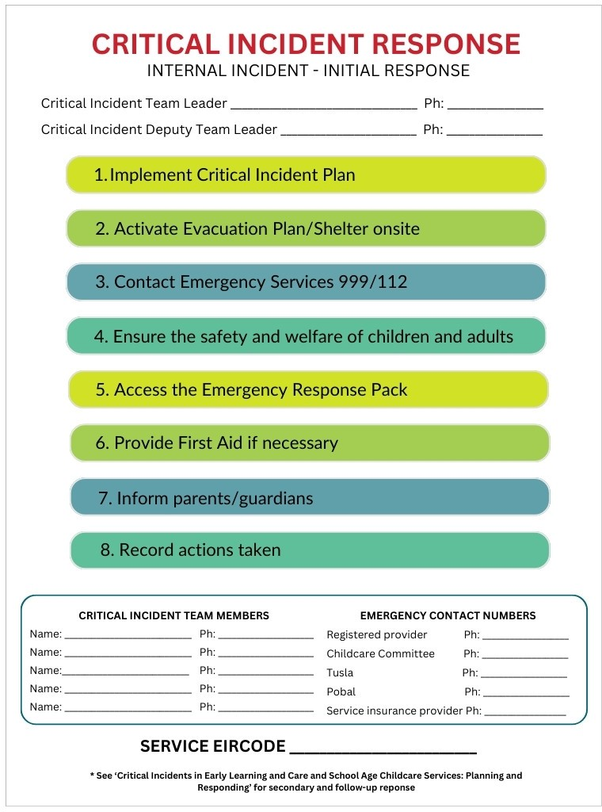This poster outlines the key actions to be taken in response to a critical incident. You can print and display this poster in your setting, somewhere it will be easily accessed in an emergency situation.

## Response Records

### Operational Procedure & Time Log Record

|  |  |  |
| --- | --- | --- |
| **Emergency/Incident: Time of Initiation:** | | **Date: Time of Stand down:** |
| **Actions**  ***(Where an action was not required write N/A)*** | **Time** | **Comments** |
| Critical Incident Team Leader (or deputy) identified |  |  |
| Critical Incident team members (or deputies) contacted |  |  |
| Appropriate Critical Incident Plan initiated |  |  |
| Child/staff safety assessed |  |  |
| Outside sources contacted  🖵 CCC  🖵 An Garda Síochána  🖵 Ambulance  🖵 Fire Brigade |  |  |
| Fire alarm activated (if appropriate) |  |  |
| Evacuation/lock down procedure enacted (if appropriate) |  |  |
| Children moved to relocation site  Add daily sign-in sheet to emergency response pack |  |  |
| Duties delegated to staff  🖵 First Aid  🖵 Evacuation of children  🖵 All entrances secured   * Front door * Emergency exits   🖵 Assistance sought for evacuation  🖵 Secure site |  |  |

|  |  |  |
| --- | --- | --- |
| Off duty staff contacted |  |  |
| All parents and guardians contacted |  |  |
| Services cancelled (if appropriate) |  |  |
| Collection of children organised |  |  |
| Impact on electricity supply assessed by appropriate professional |  |  |
| Impact on gas supply assessed by appropriate professional |  |  |
| Impact on water supply assessed by appropriate professional |  |  |
| Impact on other services assessed by appropriate professionals |  |  |
| Impact on security assessed |  |  |
| Infection risk assessed using appropriate guidance |  |  |
| P.R. issues addressed |  |  |
| *Outside services involved |  |  |
| Supply of specialist equipment located |  |  |
| Approved subcontractors identified |  |  |
| Record specialist contractor contact details |  |  |
| Stand down called by Critical Incident Team Leader |  |  |
| **Critical Incident Team Leader Signature: _ Date: Service Owner/Manager Signature: Date:**  *(If different from above)* | | |

*\*An example of this would be specialist cleaning services in the event of a flood*

### Record of Support Provided

*This form can be amended to suit your individual Early Learning and Care or School Age Childcare service.*

This form can be used by staff to record the details of support given to children and parents following a critical incident. This information should be collated centrally.

|  |  |  |  |  |  |  |
| --- | --- | --- | --- | --- | --- | --- |
| **Date** | **Staff Name** | **Child’s Name** | **Parent/ Guardian Name** | **ELC/SAC**  **Room Child is Attending** | **Type of Support Offered** | **OUTCOME (include need for follow- up)** |
|  |  |  |  |  |  |  |
|  |  |  |  |  |  |  |
|  |  |  |  |  |  |  |
|  |  |  |  |  |  |  |
|  |  |  |  |  |  |  |
|  |  |  |  |  |  |  |
|  |  |  |  |  |  |  |
|  |  |  |  |  |  |  |
|  |  |  |  |  |  |  |
|  |  |  |  |  |  |  |
|  |  |  |  |  |  |  |
|  |  |  |  |  |  |  |
|  |  |  |  |  |  |  |
|  |  |  |  |  |  |  |
|  |  |  |  |  |  |  |
|  |  |  |  |  |  |  |
|  |  |  |  |  |  |  |
|  |  |  |  |  |  |  |
|  |  |  |  |  |  |  |
|  |  |  |  |  |  |  |
|  |  |  |  |  |  |  |

## Communication Templates

### Sample Communication Template 1 - Letter to Parents/Guardians - Sudden Death/Accident

The sample draft below can be used as a template for Early Learning and Care and School Age Childcare settings to inform parents of a tragedy, whether this is by letter or through digital communication. It outlines brief details of the incident and, in the event of a death, some positive remembrances of the person lost, as well as offering some advice and outlining what the service response involves.

*The text can be amended to suit your individual Early Learning and Care or School Age Childcare service and the specifics of the incident. It can also be amended to suit the age and stage of development of children in the setting. Do not include the name of any person or persons, or the family name of those involved in the incident until the details have been officially released by An Garda Síochána.*

##### Date

Dear (*Parent/Guardian)*

*(Name of service)* has experienced/learned of (*incident, e.g. the sudden death, accidental death/injury)* of *(name of staff/ child /parent as applicable)*. We are deeply saddened by (*the death/event)*. Our thoughts are with (*family name*).

We have implemented our Critical Incident Plan and have sought support. Our service will continue to operate as usual. We anticipate that the next few days will be difficult for everyone, and want to assure you that we will continue to do all we can to support the children and you through this difficult time.

With your consent, our service will give the children information about the incident appropriate to their age and stage of development so they know they can talk openly about what has happened with us. This (*death/accident*) may cause a variety of reactions in your child. Some children may be afraid for their own life and for the lives of those they love. They may want to discuss what has happened with you. Take time to listen to your child’s fears and questions and reassure them that what has happened is rare. It is important to give children true information that is appropriate for their age. We are available to discuss the information with you and support you with any questions you or your child may have and we will get through this together.

The family liaison person for our setting is *(name of person)* and the contact details are (*phone and email*).

**Optional additions**

There will be a room in the service with tea and coffee open tomorrow for parents to drop in if you should wish to do so. *AND/OR* An information meeting for parents is planned for (*date, time and place*). At that time, we will offer further information about how to help children who may be grieving or distressed.

Members of the media are in the local area and may approach you or your children. You need not respond to their questions. We will not allow anyone to interview children or staff members in our service and our general advice is not to let your children be interviewed.

**Relevant to School Age Childcare Services**

In these times, people may turn to social media to see what others are saying about the incident, or to find out more. While social media may provide consolation to some, it is important that you monitor your child’s use and engage with them about what they read. We also urge you to emphasise and reinforce the need to be extremely sensitive and careful about what they post.

Posts on social media at this time may cause further distress so, apart from condolences, information posted on social media should only be posted with the family’s consent

Please don’t hesitate to come and chat with us should you have any questions or concerns, our door is always open.

*(Service Manager’s signature)*

on behalf of (*name of service*)

### Sample Communication Template 2 - Letter to Parents/Guardians – Severe Damage to Building or Facilities

The sample draft below can be used as a template for Early Learning and Care and School Age Childcare settings to inform parents of severe damage to the building or facilities, whether this is by letter or through digital communication. It outlines brief details of the incident and offers some advice and outlining what the service response involves.

*The text can be amended to suit your individual Early Learning and Care or School Age Childcare service and the specifics of the incident. It can also be amended to suit the age and stage of development of children in the setting. Do not include the name of any person or persons involved in the incident until the details have been officially released by An Garda Síochána.*

##### Date

Dear (*Parent/Guardian)*

We are writing to update you on the unfortunate events that have led to severe damage to (*name part of service/building)*. We are extremely upset and regret that this has happened but are most grateful that all of the children and all members of the staff team are safe and well.

We have implemented our Critical Incident Plan and (*state what is happening now, e.g. there will be an investigation/we have commenced the clean up and repair*)*.*

We will be operating out of temporary premises at (*location*) OR Unfortunately, we will be unable to operate our service for (*length of time if known/for the foreseeable future*) but will provide some play and learning resources to help you until we can return to operation.

Some of the children are understandably a bit stressed after this event. **Optional addition if service is still operating -** We are doing our best to explain what has happened and to reassure and comfort them.

#### This incident may cause a variety of reactions in your child. Some children may be afraid of what might happen next. They may want to discuss what has happened with you. Take time to listen to your child’s fears and questions and reassure them that what has happened is rare. It is important to give children true information that is appropriate for their age. We are available to discuss the information with you and support you with any questions you or your child may have and we will get through this together.

The family liaison person for our setting is *(name of person)* and the contact details are (*phone and email*). Please feel free to contact them. There may be a slight delay in hearing back as there will be lots of contacts to respond to, but we will get back to you as soon as we can.

#### We will be in contact with you again at the earliest possible time to keep you updated on the situation.

##### (Service Manager’s signature)

on behalf of (*name of service*)

### Sample Communication Template 3 - Sample Announcement to the Media

The following can be used as a template for Early Learning and Care and School Age Childcare settings when communicating with the media.

*The text can be amended to suit your individual Early Learning and Care or School Age Childcare service and the specifics of the incident. Do not include the name of any person or persons, or family name of anyone involved in the incident until the details have been officially released by the Gardaí.*

My name is (*Name*) and I am the Manager of (*Service name).*

#### Message Starts

We learned this morning of the death of one of our (*children/staff members*). We are deeply saddened by these events. Our sympathy and thoughts are with their family and friends.

(*Name of child/staff member/They*) will be greatly missed by all who knew them.

#### We have been in contact with the bereaved parents/family and they have requested that we all understand their need for privacy at this difficult time.

Offers of support have been pouring in and are greatly appreciated. Our service has implemented our Critical Incident Plan and we have sought support from (*Name and role/ purpose of agency*).

#### The staff team is being supported to help the children and their families to deal with this tragic event.

Our Early Learning and Care/School Age Childcare service remains open to our families to support them and to offer them advice and guidance.

#### Our primary concern is the wellbeing of the children, families and staff team in our setting and so we ask that you respect our privacy at this time.

##### (Service Managers signature)

on behalf of *(name of service)*

## Useful Links

Regulations, guidelines and frameworks

Child Care Act 1991 (Early Years services) Regulations 2016

[Child Care Act 1991 (Early Years Services) (Registration of School Age Services) Regulations 2018](https://www.irishstatutebook.ie/eli/2018/si/575/made/en/print)

[National Quality Guidelines for School Age Childcare Services](https://assets.gov.ie/88025/5e6c734d-7d21-47f2-ae28-b84b581939d9.pdf)

[Tusla Quality and Regulatory Framework (QRF)](https://www.tusla.ie/services/preschool-services/early-years-providers/early-years-provider-resources/early-years-quality-and-regulatory-framework/)

[Tusla practice guidance for developing policies, procedures and statements](https://www.tusla.ie/uploads/content/4572-TUSLA_QRF_POLICY_PROCEDURES_LR.pdf)

Bereavement supports

[Barnardos – bereavement https://www.barnardos.ie/resources/bereavement](https://www.barnardos.ie/resources/bereavement) [Irish Hospice Foundation](https://hospicefoundation.ie/our-supports-services/bereavement-loss-hub/childrens-bereavement/)

<https://hospicefoundation.ie/our-supports-services/bereavement-loss-hub/childrens-bereavement/> [The Irish Childhood Bereavement Network https://www.childhoodbereavement.ie/](https://www.childhoodbereavement.ie/)

Other useful resources

[BeSmart - Safety management and Risk Assessment](https://besmart.ie/) https://BeSmart.ie [Health and Safety Authority www.hsa.ie/eng/](http://www.hsa.ie/eng/)

[Healthy Ireland – Minding Your Mood](https://www.gov.ie/en/publication/c803e-managing-your-mood/) https://[www.gov.ie/en/publication/c803e-managing-your-mood/](http://www.gov.ie/en/publication/c803e-managing-your-mood/) [HSE – Child Safety](https://www2.hse.ie/babies-children/child-safety/) https://www2.hse.ie/babies-children/child-safety/

[National Educational Psychological Service (NEPS) – Critical Incidents](https://www.gov.ie/en/service/5ef45c-neps/#critical-incidents) https://[www.gov.ie/en/service/5ef45c-neps/#critical-incidents](http://www.gov.ie/en/service/5ef45c-neps/#critical-incidents)

[The Royal Society for the Prevention of Accidents www.rospa.com/](http://www.rospa.com/) [Poisons Information Centre of Ireland www.poisons.ie/](http://www.poisons.ie/)